Knowledge-base, Machine Learning, Deep Learning Comparative Analysis

Erwin Yonata   
*Computer Science*  
*Sampoerna University*Jakarta, Indonesia  
erwinwingyonata@gmail.com

*Abstract*—This study provides a comprehensive comparative examination of three important AI paradigms: knowledge-based systems, classical machine learning, and current deep learning. We begin by discussing the historical development and core goals of each approach, which range from rule-driven expert systems that rely on explicit knowledge representations and logical inference to statistical learning algorithms that require manual feature engineering to multi-layered neural architectures capable of automated hierarchical feature extraction. A thorough examination of representative models and techniques is offered, emphasizing significant breakthroughs (e.g., MYCIN, decision trees, support vector machines, CNNs, RNNs, Transformers) and the issues they address. Technical topics such as knowledge representation, inference techniques, learning objectives, data needs, scalability, and interpretability are thoroughly examined. To objectively assess performance differences, we replicated and compared exemplary implementations of each paradigm on the Titanic survival prediction task: an experta-based rule engine, logistic regression, and a fully connected neural network. The findings show the trade-offs between human-encoded consistency, data efficiency, and predictive accuracy in small-scale versus large-scale data sets. Our findings shed light on the developing AI landscape and provide advice for adopting relevant approaches in data-driven applications.

Keywords—knowledge-based system, machine learning, deep learning, comparative analysis, expert systems, neural networks, AI paradigms, Titanic dataset.

# Introduction

Humans started civilization by going through many obstacles and the industrial era until today. The industrial era itself consists of five eras, namely 1.0 marked by steam engines and mass production, 2.0 marked using electricity making production cheaper and more efficient, 3.0 marked by the emergence of the internet and digital technology that accelerates communication and production, and 4.0 marked by the presence of artificial intelligence, connectivity, and automation in various aspects of production and life. At this time, artificial intelligence technology has been widely used in many industrial fields and everyday life.

Such as implementing an industrial automation system using object detection, a traffic ticketing automation system using person detection, performing automatic reading using OCR (Optical Character Recognition).

## Artificial intelligence

### Knowledge-based System (KBG): Primarily a computer program meant to handle complicated issues by leveraging two essential components: an explicit knowledge base and a reasoning mechanism, sometimes known as an inference engine [3]. Serves as a repository for domain-specific facts, rules, and heuristics, representing an attempt to capture the relevant understanding of a particular field. KGB were predominantly the focus of AI researchers during the 1980s. Symbolic AI or Good Old-Fashioned AI (GOFAI), emphasizing its reliance on symbolic manipulation and explicit logical rules [4]. Early symbolic techniques in the 1950s and 1960s had high aspirations, but technical restrictions resulted in the first AI Winter in the 1970s. A comeback occurred in the 1980s with expert systems, which demonstrated effectiveness in restricted domains but eventually encountered challenges such as brittleness and the knowledge acquisition bottleneck, resulting in another fall [5]. These issues pushed the field towards machine learning and new paradigms. This cycle of excitement and setbacks sheds light on contemporary deep learning advances, which also raise worries about sustainability and generalizability.

### Machine Learning: Spans roughly from the mid-twentieth century, with the first concepts of artificial intelligence, until the early 2010s. This timeframe is broadly defined by the basic work in neural networks and learning theories, and it culminates right before the widespread adoption and eventual supremacy of deep learning approaches [6]. Enabled the ability of computers to learn from data and enhance their performance on particular tasks without requiring explicit programming for every detail of those operations. The fundamental ideas were mathematical optimization, statistical techniques, and—most importantly—the clear, human-driven description of data attributes. Classical machine learning, which came before deep learning, was distinguished by its strong reliance on manual feature engineering, in which specialists painstakingly created input characteristics that were essential to model performance [7]. These models usually needed extensive data preprocessing and performed best on smaller, structured datasets. Classical algorithms were easier to use and frequently performed well on conventional CPUs due to their lower computational requirements. However, this limited their ability to solve extremely complicated problems. Compared to contemporary deep learning techniques, they may not have been as able to capture extremely complex, non-linear patterns, but one of their main advantages was their increased interpretability, with many models providing transparent decision-making processes.

### Deep Learning: Deep learning is one of the branch subjects of machine learning. It is a very extraordinary evolution, because deep learning uses a structure that is almost the same as the human brain, starting with dendrites, axons, and synapses that are interconnected to produce a decision. Walter Pitts and Warren McCulloch created the first computer based on neural networks of the human brain, using an algorithm called "threshold logic" to mimic the though process and known as early conceptual ancestor [1]. Primary obejctive of deep learning is to make system that can recognize pattern, automated feature extraction, predicting and making decision [2].

# Result and Discussion

Thorough comparative study is necessary due to the significant benefits that deep learning offers over conventional knowledge-based systems and traditional machine learning techniques. This section offers a thorough analysis of each system's structural underpinnings, intrinsic advantages and disadvantages, and real-world applications. By analyzing the differences between knowledge-based systems, machine learning models, and deep learning architectures in terms of methodological construct, data requirements, scalability, interpretability, and real-world applicability, the comparison seeks to clarify the changing paradigms in intelligent system design. To better comprehend each paradigm's applicability across different domains and use cases—especially in the context of increasingly data-driven environments—such an examination is crucial.

## Objective

In this section, a comprehensive analysis of the objective of each system will be conducted.

### Knowledge-based system: Known as the early concept of artificial intelligence, KBS categorized as expert systems, intelligent tutoring systems, hypertext manipulations systems, CASE-based systems, and databases having an intelligent user interface. In specialized domains where human expertise may be limited, a KBS aims to enable decision-making, consistency, and problem-solving by explicitly capturing and representing expert domain knowledge and using logical inference, such as forward/backward chaining [8]. The objective was to create systems that could use clearly encoded knowledge to reason and make judgments similarly to human cognitive processes, as opposed to solely depending on procedural code [3].

Figure 1. Knowledge-based system illustration [21]

### Machine learning: Concern with the development of statistical algorithms that can learn from data and generalize to unseen data, machine learning has an objective to automatically discover patterns in dataset, making predictive models, and enable systems to improve performance on task over time. With the goal of empowering computer systems to enhance their performance on certain tasks by learning from data, without the need for explicit programming for every detail of that activity [13]. Overcome the drawbacks of symbolic AI, especially the brittleness of rule-based systems in unfamiliar or unclear situations and the information acquisition bottleneck (the challenge of manually encoding all relevant knowledge) [14].

### Deep Learning: Focused on utilizing multi-layered artificial neural networks, the objective of deep learning is to automatically learn complex features and representation from large volumes of unstructured data without manual feature engineering to achieve state-of-the-art performance [9].

Figure 2. Multi-layered artificial neural networks [25]

Simulating complex decision-making capabilities of the human brain by using artificial neural networks with multiple layers to enable automatic hierarchical feature learning [18].

## Survey of what has been done by researchers

In this section, a comprehensive analysis of the survey of what has been done by researchers of each system will be conducted.

### Knowledge-based system: Research has been conducted variously and focused on developing expert systems, like MYCIN (medical diagnosis), DENDRAL (chemical analysis), and XCON (computer configuration) were created to demonstrate human knowledge [10].

Establishing knowledge representation (KR) techniques, rule-based representations (IF-THEN structures), logic programming (e.g., using Prolog), semantic networks (graphical representations of concepts and relationships), frames (structured representations of stereotypical situations), and ontologies (formal specifications of domain concepts and relationships) [11]. Investigating the knowledge acquisition (KA), how to efficiently extract, organize, and record knowledge from human specialists. This included techniques such as protocol analysis, domain literature research, and interviews [12].

### Machine learning: Development of learning paradigm supervised (training on labeled data), unsupervised (training on un-labeled data), and reinforcement (training agents to make sequences of decisions) [15]. Diverse algorithms have also been developed, decision trees, support vector machines (SVM), k-nearest neighbors (KNN), logistic regression, naïve bayes, and ensemble methods [16]. Advancement of training techniques using backpropagation, that was significantly improved for neural networks, has become the foundational concept for training machine learning models.

### Deep Learning: Innovation on architecture, including Convolutional Neural Network (CNN), Recurrent Neural Network (RNN), LSTM, GRU, Transformers (self-attention mechanism), Generative Adversarial Networks (GAN), and AutoEncoder (AE) [19]. Training optimization techniques (e.g. ADAM, SGD, ReLU), data efficiency research focuses on techniques like few-shot learning (learning from new examples) and zero-shot learning (learning without direct examples of a class). KADL (Knowledge-Augmented Deep Learning) is an effort to combine deep learning with symbolic knowledge [20].

## Technical details

In this section, a comprehensive analysis of the technical details of each system will be conducted. Procedure the problems formulated and solved, using what kind of algorithms, method for representing the information, and method for processing of information.

### Knowledge-based system: Core architecture consists of two components, knowledge base (contains facts, rules, heuristic, and relationship) and inference engine (applies logical rules to the knowledge base). Knowledge representation methods include rule-based systems, logic programming, semantic networks, frames, and ontologies. Information processing (reasoning) includes forward chaining and backward chaining.

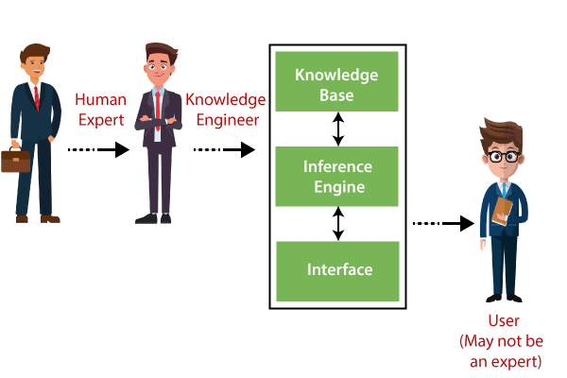

Figure 3. Knowledge base and inference engine [22]

### Machine learning: Problems are commonly framed as supervised, unsupervised, and reinforcement learning tasks. Using various algorithms to model data and learn patterns, for example linear models, tree models, instance-based models, and probabilistic models). Information processing involves modelling and optimizing the trained model, it can be minimizing a loss function which is responsible for measuring errors between predictions and actual values as the goal to generalize well to unseen data [17].

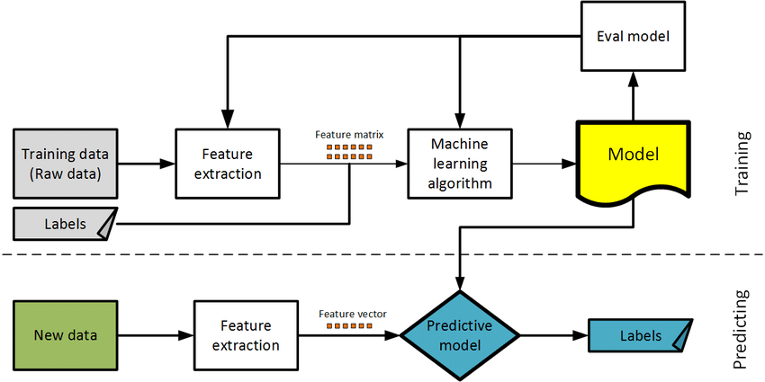

Figure 4. ML supervised learning training flow [23]

Above is an example of supervised learning, the flow for training a model starts with training data (raw) + labels, next the important features inside the training data will be extracted by chosen algorithms (e.g. BoW, TF-IDF, NER, MFCC). Then, extracted features get fed into the ML algorithm + evaluated using chosen metric, then the loop cycle of training began. After that, a predictive model was produced and being deployed. Finally, the predictive model can be used for real world new data for predicting certain values.

### Deep Learning: The foundation element for deep learning is Artificial Neural Networks (ANNs) with multiple hidden layers [18]. Information represented in different forms, including tensors (multi-dimensional array), embeddings (dense vector representations), and hierarchical feature learning (effect of number of layers to learning). Information processing includes forward propagation (data computed then passed to activation function), back propagation (calculate the gradient loss), gradient descent (optimization algorithm, for example stochastic gradient descent (SGD)), and attention mechanism (allow weight the importance of different parts of the input).

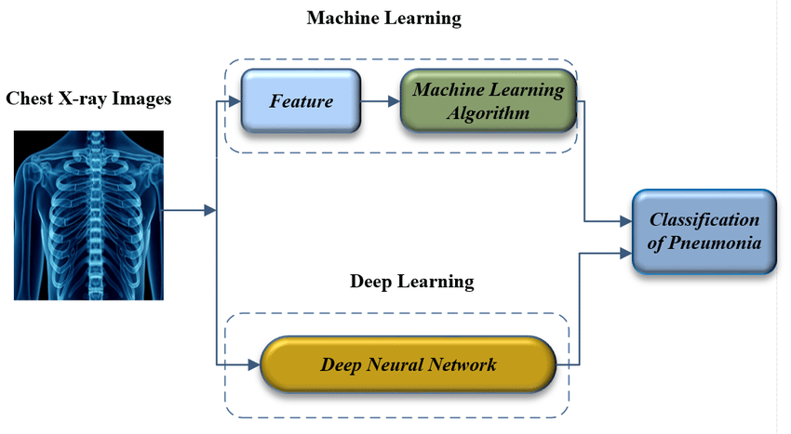

Figure 5. Difference machine learning with deep learning [24]

The difference between machine learning and deep learning doesn’t need feature extractors, as it processes raw data and finds the important feature automatically. This makes deep learning more precise at selecting the important feature than machine learning that depend on hardcoded algorithm to do feature extraction.

## Reproduce implementation

In this section, a comprehensive analysis of the reproducing system developed by the researcher and of each system will be conducted. In these experiments, will be conducted comparison between three systems with the same dataset (titanic dataset).

### Knowledge-based system:

|  |
| --- |
| import collections  import collections.abc  # Re-expose the moved ABCs on the old module  collections.Mapping = collections.abc.Mapping  collections.MutableMapping = collections.abc.MutableMapping  collections.Sequence = collections.abc.Sequence  # Now safe to import experta  from experta import KnowledgeEngine, Fact, Rule, P\  class Passenger(Fact):  """Represents one Titanic passenger."""  pass  class TitanicExpertSystem(KnowledgeEngine):  @Rule(Passenger(sex='female'))  def female_survives(self):  print("Rule: Female → Survived")    @Rule(Passenger(age=P(lambda a: a < 16)))  def child_survives(self):  print("Rule: Under 16 → Survived")  @Rule(Passenger(pclass=1))  def first_class(self):  print("Rule: 1st Class → Higher survival chance")  @Rule(Passenger(sex='male', age=P(lambda a: a >= 16), pclass=P(lambda c: c > 1)))  def male_other(self):  print("Rule: Adult male in lower class → Did Not Survive")  if __name__ == "__main__":  engine = TitanicExpertSystem()  engine.reset()  # Example passenger  engine.declare(Passenger(sex='male', age=8, pclass=3))  engine.run() |

In knowledge-based system it used if-else statement for constructing the output. With this architecture, the result always be consistent according to an expert person who coded the knowledge base. With the spike of data today, this method is a burden to implement. For example, when user enter ‘sex’=male, ‘age’=8, ‘pclass’=3, the output will be ‘Rule: Under 16 → Survived’. It triggered a certain rule to decide the output.

### Machine learning:

|  |
| --- |
| import pandas as pd  import seaborn as sns  from sklearn.model_selection import train_test_split  from sklearn.linear_model import LogisticRegression  from sklearn.metrics import accuracy_score, classification_report  # 1. Load & preprocess  # Load the Titanic dataset from seaborn  ori_df = sns.load_dataset('titanic')  ori_df['age'].fillna(ori_df['age'].median(), inplace=True)  df = pd.get_dummies(ori_df[['pclass','sex','age','sibsp','parch','fare']], drop_first=True)  y = ori_df['survived']  # 2. Split  X_train, X_test, y_train, y_test = train_test_split(  df, y, test_size=0.3, random_state=42  )  # 3. Train  clf = LogisticRegression(max_iter=200)  clf.fit(X_train, y_train)  # 4. Predict & evaluate  y_pred = clf.predict(X_test)  print("Accuracy:", accuracy_score(y_test, y_pred))  print(classification_report(y_test, y_pred)) |

Above is the code for machine learning using logistic regression algorithm for binary classification problems.

Table 1. Result logistic regression

|  |  |  |  |  |
| --- | --- | --- | --- | --- |
| **Class** | **Precision** | **Recall** | **F1-score** | **Support** |
| 0 | 0.81 | 0.89 | 0.85 | 157 |
| 1 | 0.81 | 0.71 | 0.76 | 111 |
| **Overall Accuracy** | | | | 0.81 |

From the result machine learning try to understand the features inside the dataset, it achieved overall accuracy 0.81. Without being explicitly told by engineers, the system can learn by itself and store the information this knowledge-based system lacks on.

### Deep Learning:

|  |
| --- |
| import pandas as pd  import seaborn as sns  import tensorflow as tf  import numpy as np  from tensorflow.keras import layers, models  # 1. Load & preprocess  # Load the Titanic dataset from seaborn  ori_df = sns.load_dataset('titanic')  ori_df['age'].fillna(ori_df['age'].median(), inplace=True)  X = pd.get_dummies(ori_df[['pclass','sex','age','sibsp','parch','fare']], drop_first=True).to_numpy(dtype=np.float32)  y = ori_df['survived'].values  # 2. Split  from sklearn.model_selection import train_test_split  X_train, X_val, y_train, y_val = train_test_split(  X, y, test_size=0.2, random_state=42  )  # 3. Build model  model = models.Sequential([  layers.Dense(64, activation='relu', input_shape=(X_train.shape[1],)),  layers.Dropout(0.3),  layers.Dense(32, activation='relu'),  layers.Dense(1, activation='sigmoid')  ])  model.compile(optimizer='adam',  loss='binary_crossentropy',  metrics=['accuracy'])  # 4. Train  model.fit(X_train, y_train, epochs=200, batch_size=32, validation_data=(X_val, y_val))  # 5. Evaluate  loss, acc = model.evaluate(X_val, y_val)  print(f"Validation accuracy: {acc:.3f}") |

Above is the code for deep learning multiple layered ANN model for binary classification problems.

|  |  |  |  |  |
| --- | --- | --- | --- | --- |
| **Class** | **Precision** | **Recall** | **F1-score** | **Support** |
| 0 | 0.795 | 0.848 | 0.820 | 105 |
| 1 | 0.761 | 0.689 | 0.723 | 74 |
| **Overall Accuracy** | | | | 0.782 |

From the result above, the result is worse than machine learning. This is because deep learning needs more data to be able to learn precisely, here the dataset only 891 rows and only using 712 rows for training and 179 rows for testing. Machine learning uses immediate feature extraction that enables them to learn more precise than deep learning.

# Conclusion

From the discussion and experiments conducted above using the knowledge-based system, machine learning, and deep learning. It can be concluded that the development of AI technology starts from hard instructions made by experts, but due to the ineffectiveness of the AI ​​modeling process, a more robust and flexible machine learning is formed regarding the size of the data being processed. Deep learning is almost the same as machine learning, but the development imitates how humans make predictions by imitating the working principles of brain neurons. Deep learning is a favorite in this era, making it a fundamental structure of today's AI programs that could process very large data without problems.

##### References

1. K. D. Foote, “A brief history of deep learning,” DATAVERSITY, Oct. 29, 2024. <https://www.dataversity.net/brief-history-deep-learning/>.
2. “What is deep learning? | SAP.” <https://www.sap.com/denmark/resources/what-is-deep-learning>
3. Wikipedia contributors, “Knowledge-based systems,” Wikipedia, Aug. 18, 2024. <https://en.wikipedia.org/wiki/Knowledge-based_systems>
4. A. Shaw, “The evolution of artificial intelligence: From concept to reality,” QSR, Jan. 30, 2024. <https://www.qsrailab.com/the-evolution-of-artificial-intelligence-from-concept-to-reality/>
5. L. GmbH, “Complete history of AI | LeanIX.” <https://www.leanix.net/en/wiki/ai-governance/history-of-ai>
6. R. Koch and R. Koch, “History of Machine Learning – A Journey through the Timeline,” clickworker.com, Oct. 08, 2024. <https://www.clickworker.com/customer-blog/history-of-machine-learning/>
7. Wikipedia contributors, “Outline of machine learning,” Wikipedia, Apr. 15, 2025. <https://en.wikipedia.org/wiki/Outline_of_machine_learning>
8. KMS lighthouse, “What is Knowledge-Based System? Types & Advantages,” KMS Lighthouse, Apr. 20, 2025. <https://kmslh.com/glossary/knowledge-based-system/?utm_source=chatgpt.com>
9. Wikipedia contributors, “Deep learning,” Wikipedia, May 13, 2025. <https://en.wikipedia.org/wiki/Deep_learning>
10. D. Potenza, “AI History: the 1980s and expert systems,” Klondike, Jun. 07, 2023. <https://www.klondike.ai/en/ai-history-the-1980s-and-expert-systems/>
11. V. Corporation, “Knowledge-Based systems,” Virtusa Corporation, Apr. 07, 2021. <https://www.virtusa.com/digital-themes/knowledge-based-systems>
12. DeepAI, “Knowledge Engineering,” DeepAI, Jun. 25, 2020. <https://deepai.org/machine-learning-glossary-and-terms/knowledge-engineering>
13. L. Emma, "The Evolution of Artificial Intelligence: From Symbolic AI to Deep Learning," 03/16 2025
14. S. Bello, “SmythOS - Symbolic AI vs. Machine Learning: A Comprehensive Guide,” SmythOS, Jan. 31, 2025. <https://smythos.com/ai-agents/ai-tutorials/symbolic-ai-vs-machine-learning/>
15. J. Rudi, “What is Machine Learning? Key concepts and Real-World uses,” iSchool | Syracuse University, Feb. 26, 2025. <https://ischool.syracuse.edu/what-is-machine-learning/>
16. Anaconda, “Deep Learning vs. Machine Learning: What’s the Difference?,” Anaconda, Oct. 18, 2024. <https://www.anaconda.com/topics/deep-learning-vs-machine-learning>
17. H. Patel, “Feature Engineering explained,” Built In, Apr. 29, 2024. <https://builtin.com/articles/feature-engineering>
18. Ibm, “Deep learning,” What is Deep Learning, May 05, 2025. <https://www.ibm.com/think/topics/deep-learning>
19. I. D. Mienye and T. G. Swart, “A comprehensive review of deep learning: architectures, recent advances, and applications,” Information, vol. 15, no. 12, p. 755, Nov. 2024, doi: 10.3390/info15120755.
20. B. C. Colelough and W. Regli, “Neuro-Symbolic AI in 2024: A Systematic review,” arXiv.org, Jan. 09, 2025. <https://arxiv.org/abs/2501.05435>
21. “Expert Systems and Applied AI — EITC.” <http://www.eitc.org/research-opportunities/new-media-and-new-digital-economy/ai-machine-learning-deep-learning-and-neural-networks/ai-research-and-applications/expert-systems-and-applied-ai>
22. “Expert Systems in Artificial Intelligence - TPoint Tech,” www.tpointtech.com. <https://www.tpointtech.com/expert-systems-in-artificial-intelligence>
23. D. Nguyen, C. Nguyen, N. T. Duong-Ba, H. Nguyen, A. Nguyen, and T. Tran, “Joint network coding and machine learning for error-prone wireless broadcast,” 2022 IEEE 12th Annual Computing and Communication Workshop and Conference (CCWC), pp. 1–7, Jan. 2017, doi: 10.1109/ccwc.2017.7868415.
24. R. E. A. Mamlook, S. Chen, and H. F. Bzizi, “Investigation of the performance of machine learning classifiers for pneumonia detection in chest x-ray images,” Investigation of the Performance of Machine Learning Classifiers for Pneumonia Detection in Chest X-ray Images, pp. 098–104, Jul. 2020, doi: 10.1109/eit48999.2020.9208232.
25. R. Nuzzi, G. Boscia, P. Marolo, and F. Ricardi, “The Impact of Artificial intelligence and deep Learning in eye Diseases: a review,” Frontiers in Medicine, vol. 8, Aug. 2021, doi: 10.3389/fmed.2021.710329.